What to Bring to When Starting…
- Paperwork if still needed to be turned in
- Copy of latest health report

Meals:
- Bring a lunch meal daily (as needed) in a LABELED lunchbox. (Use an ice pack if it must be kept cool.) Microwave available for quick heating, nothing frozen.
- Bring water daily in a LABELED water bottle/Sippy cup for outside.
We provide morning and afternoon snacks and drink. We provide breakfast for children who arrive before 8 am. We fill up water bottles as needed.
- Reminder: Lunches is available daily for $4.50. Menu is sent monthly through email.

Toileting:
- ALL children- Bring in a LABELED packs of wipes for your child’s cubby.
- Bring diapers as needed. (You can bring in a small LABELED package to be kept at school for when your child’s supply is running low.)
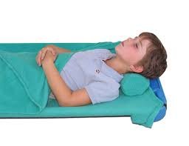
- We will send home a note when diapers and/or wipes supply is running low.

Naptime:
- We use the Rolee Polee nap system (with pillow, a bottom and top cover), sold to you at our discounted rate of $23 each. (see photo above) We will send these items home at the end of each week to be washed.

Extra Clothes:
- Bring LABELED seasonally appropriate clothes to be stored in a shoebox size container (container provided).
- 2 shirts, 2 pants, a pair of socks, 2 pairs of underwear.
- We will send home soiled clothes in a plastic bag, please replenish the extra clothes bin whenever clothes are sent home.

